SIMATS ENGINEERING
DEPARTMENT OF COMPUTER SCIENCE & ENGINEERING
COURSE NAME: Computer Vision with OpenCV COURSE CODE: DSA02
COURSE OUTCOME COVERED: CO3: Analyze shape representation methods and techniques such as contours, regions, deformable models, and multi-resolution analysis. (BL4)
ASSESSMENT TOOL 2 (CASE STUDY) | Weightage: 30% | Total Marks: 30
Code of Conduct:
I Shaik Sameer (192424094) (Name / Reg No) certify that this submission is my original work and that I have adhered to the guidelines specified for this assessment. I understand that any violation of academic integrity rules will result in disciplinary action.
Signature of the student: Shaik Sameer

RUBRICS FOR CALCULATION
Criteria | Weightage | Level 4 (Exemplary) | Level 3 (Proficient) | Level 2 (Developing) | Level 1 (Beginning) | Marks
Understanding of Case | 25% | Thorough understanding; clearly identifies all key issues | Good understanding with most issues identified | Basic understanding; some issues missed | Poor understanding; problem not identified correctly
Application of Concepts | 25% | Effectively applies relevant concepts to analyze the case deeply | Applies appropriate concepts with minor gaps | Limited application of concepts | Fails to apply relevant concepts
Analysis | 20% | In-depth analysis with strong reasoning and insights | Good analysis with logical reasoning | Basic analysis with limited depth | Weak or no analysis; lacks reasoning
Solution Design | 20% | Innovative, feasible solutions with strong justification | Logical solutions with adequate justification | Basic solutions with weak justification | Incorrect or no solution provided
Clarity | 10% | Clear, well-structured, and easy to understand | Organized and understandable presentation | Limited clarity and structure | Poor clarity; difficult to understand

Case Study 1: Defect Detection in Industrial Parts
SCENARIO / INPUT DATA: Automated Gear & Component Quality Inspection
A manufacturing company wants to automatically detect defects in gears and machine components using computer vision. The images of the components are binary and may contain small protrusions or missing parts.

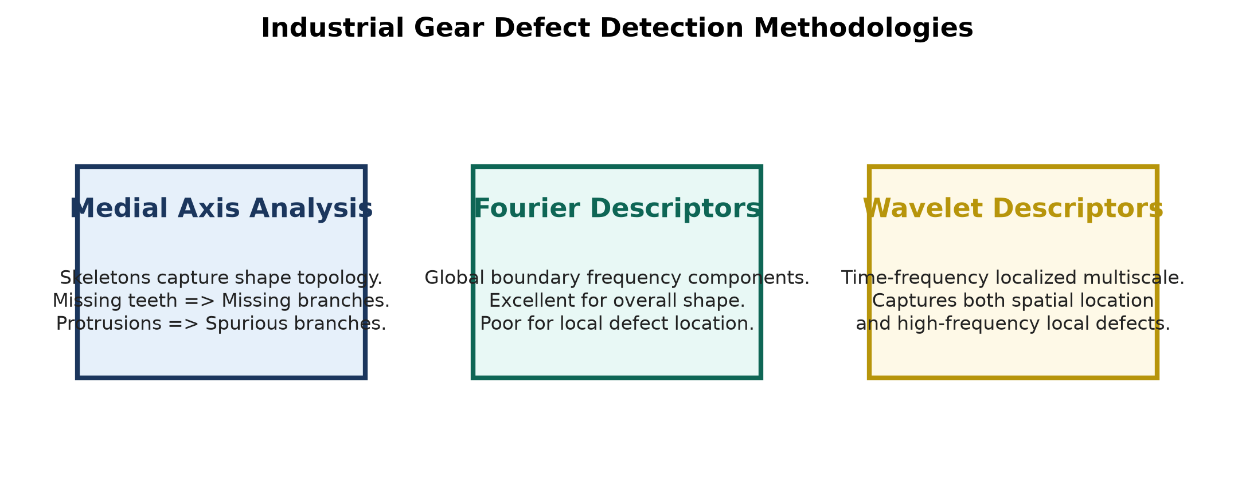
Figure 6: Comparative Methodology for Industrial Gear Defect Analysis (Medial Axis vs Fourier vs Wavelet Descriptors).
Question A: How region-based representation and medial axis computation help in identifying defective parts?
Answer:
Region-based representation analyzes the interior spatial topology of a 2D binary object rather than relying solely on boundary contours. The Medial Axis Transform (MAT) compresses an industrial component (e.g., a gear) into a 1D topological skeleton S defined by maximal inscribed disks:
S = { p in R | NOT EXISTS q in R such that B(p, D(p)) STRICTLY CONTAINED IN B(q, D(q)) }
How MAT Identifies Specific Industrial Gear Defects:
- 1. Detection of Missing Gear Teeth: A flawless N-tooth gear produces a central circular skeletal hub with exactly N radial branch arms. If a tooth is broken or missing during manufacturing, the corresponding radial skeletal arm disappears (branch count = N-1). Graph topology analysis detects this anomaly instantaneously.
- 2. Detection of Small Protrusions (Burrs / Metal Spores): Unwanted surface protrusions introduce local maximal distance peaks, giving rise to extra unwanted skeletal branches. Branch point degree counts (deg(v) >= 3) isolate the exact pixel location of burr defects.
- 3. Internal Cavity / Hole Defects: Internal air bubbles or casting holes introduce closed loops (cycles) into the skeletal graph structure, easily detected using Euler Characteristic analysis: Chi = V - E + F.
Question B: Discuss how noise in image acquisition affects shape analysis and propose preprocessing steps to improve accuracy.
Answer:
Impact of Image Acquisition Noise on Shape Analysis:
- Boundary Jaggedness & Spurious Skeletal Branches: Salt-and-pepper noise or camera sensor noise creates single-pixel boundary roughness. Because MAT is sensitive to boundary perturbations, minor noise specks generate numerous spurious skeletal branches, completely corrupting graph topology.
- Boundary Contour Distortion: Noise skews Fourier and Wavelet descriptors by introducing high-amplitude false high-frequency harmonics.
Proposed Preprocessing Pipeline:
- Step 1: Noise Removal via Median Filtering: Apply a 3x3 Median Filter to eliminate impulse noise specks without blurring sharp gear tooth edges: cv2.medianBlur(img, 3).
- Step 2: Adaptive Otsu Binarization: Convert grayscale camera images to clean binary maps using Otsu's automatic threshold selection: cv2.threshold(img, 0, 255, cv2.THRESH_BINARY + cv2.THRESH_OTSU).
- Step 3: Morphological Opening & Closing Cleanup: Apply Morphological Opening (Erosion -> Dilation) with a 3x3 structuring element to erase background noise specks, followed by Morphological Closing (Dilation -> Erosion) to fill small internal pinholes.
- Step 4: Skeleton Pruning: Apply distance-threshold pruning to remove residual minor skeletal branches shorter than a threshold T_length.
Question C: Compare the effectiveness of Fourier descriptors versus wavelet descriptors for classifying normal vs. defective components.
Answer:
Comparative Analysis Matrix:
- 1. Localization Capability: Fourier Descriptors (FDs) use sinusoidal basis functions that extend globally over the entire boundary. A local defect (e.g., a tiny missing gear tooth) alters ALL Fourier coefficients globally, making it difficult to pinpoint defect location. Wavelet Descriptors use compactly supported wavelets (e.g., Daubechies db4) that provide joint time-frequency localization, isolating the exact spatial location of localized defects.
- 2. Multi-Resolution Sensitivity: Wavelet Descriptors naturally decompose shapes into coarse approximation subbands (overall gear shape) and fine detail subbands (tooth micro-defects), enabling multi-scale hierarchical classification. FDs require arbitrary frequency truncation.
- 3. Computational Efficiency: FDs rely on 1D FFT (O(K log K) complexity). Wavelet Descriptors rely on 1D DWT (O(K) linear complexity), making Wavelet descriptors faster for real-time industrial conveyor belt inspection.
- Conclusion: Wavelet Descriptors are superior for localized defect detection (missing teeth, burrs), whereas Fourier Descriptors are preferred for global shape classification (distinguishing gears from washers).
Case Study 2: Medical Image Segmentation
SCENARIO / INPUT DATA: CT Scan Organ Boundary Segmentation
A hospital is developing a system to segment organs from CT scans. The organ boundaries are irregular and may vary slightly between patients.

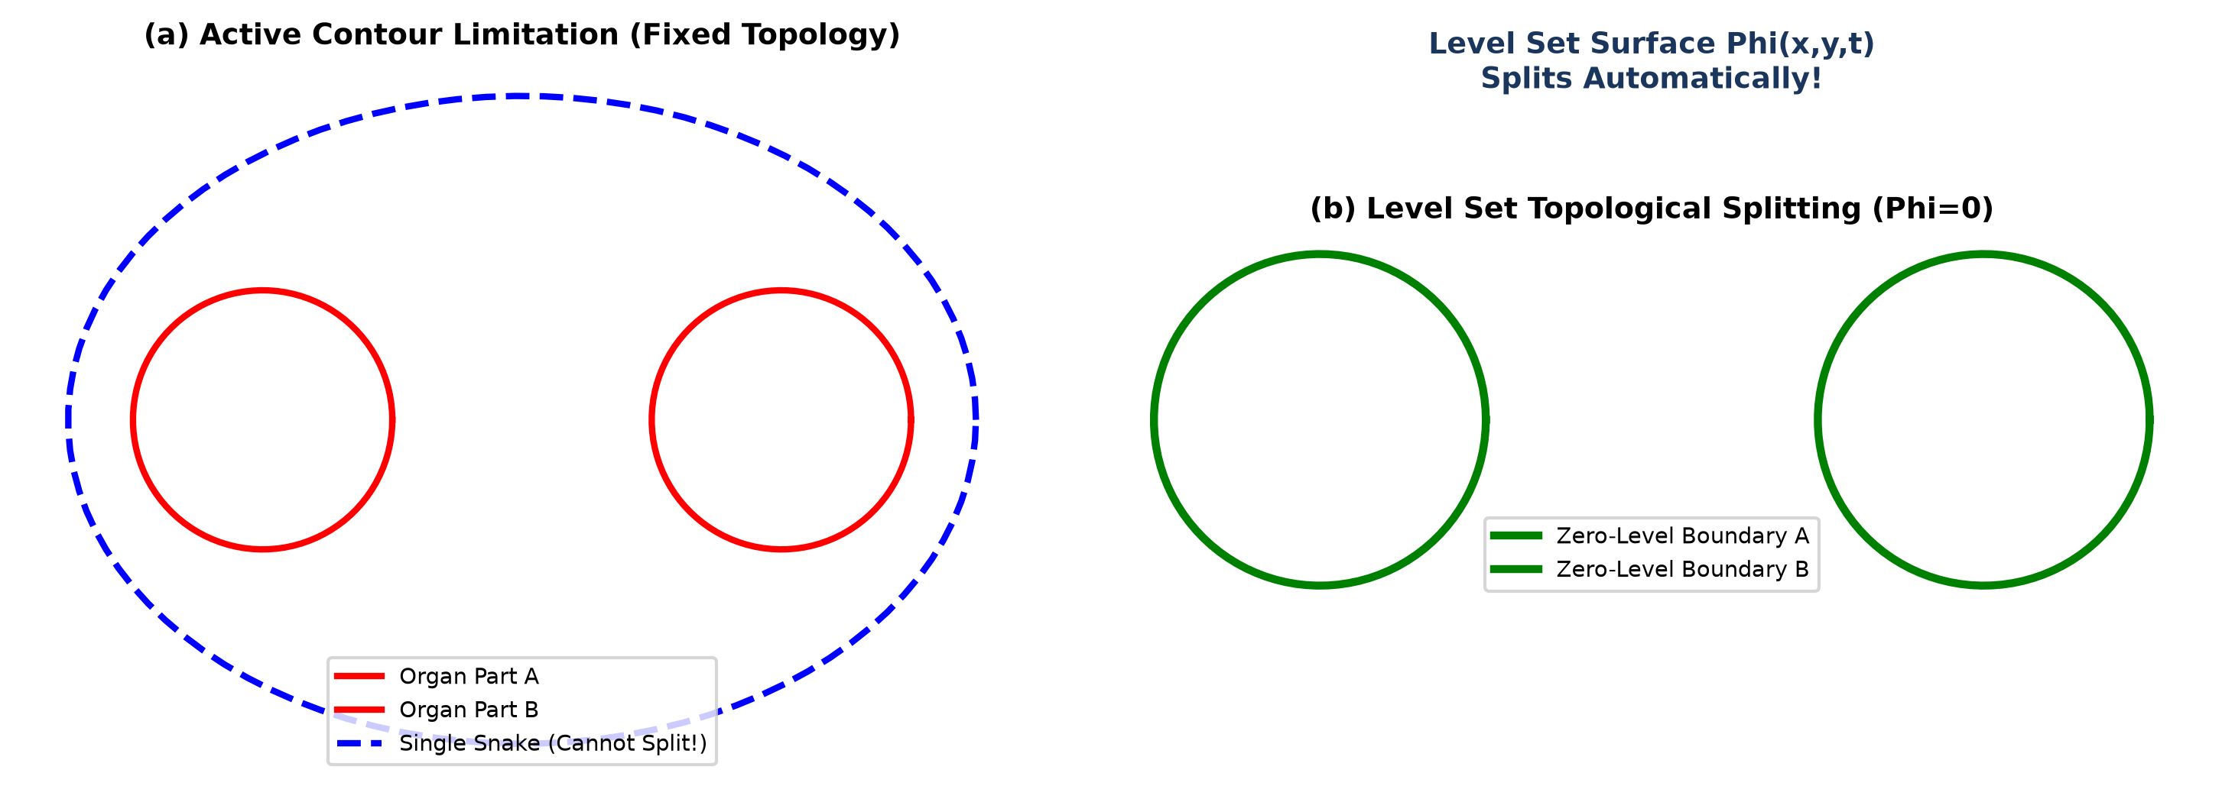
Figure 7: Comparison of Medical Organ Segmentation: (a) Active Contour Topology Limitation vs (b) Level Set Automatic Topological Splitting.
Question A: Explain how active contours (snakes) can be applied to segment the organ boundaries.
Answer:
Active Contours (Snakes) are energy-minimizing deformable curves v(s) = (x(s), y(s)) that shrink-wrap around irregular organ boundaries (e.g., liver, heart, kidneys) in CT scans by minimizing total energy:
E_snake^* = Integral_0^1 [ (1/2)*(alpha*|v'(s)|^2 + beta*|v''(s)|^2) - gamma*||Grad(G_sigma * I(x,y))||^2 ] ds
Application Steps in Medical CT Segmentation:
1. Initial Contour Placement: A clinician or automated detector places an initial bounding curve v_0(s) around the target organ.
2. Internal Force Regularization: The elasticity term (alpha) pulls the curve inward to minimize length, while stiffness (beta) resists sharp unnatural bending, smoothing irregular organ borders.
3. External Image Force Attraction: The gradient magnitude term (-gamma * ||Grad(I)||^2) pulls the curve onto high-contrast tissue-organ boundaries.
4. Iterative Energy Minimization: The curve deforms iteratively until internal and external forces reach equilibrium at the exact organ border.
Question B: Discuss the challenges of initializing contours and tuning parameters for accurate segmentation.
Answer:
Key Challenges in Active Contour Medical Segmentation:
- 1. Sensitivity to Initial Contour Placement: Snakes rely on local gradient descent. If the initial contour v_0(s) is placed too far from the true organ boundary, the external image gradient force is zero (||Grad(I)|| ≈ 0), causing the snake to collapse to a point or get trapped in local energy minima caused by adjacent anatomical structures.
- 2. Elasticity (alpha) and Stiffness (beta) Parameter Tuning: If alpha is too high, the snake over-constricts and cuts across concave organ boundaries (e.g., heart chambers). If beta is too high, the snake cannot bend to capture sharp irregular organ lobes. If gamma is too high, CT image noise traps the contour.
- 3. Weak or Blurry Medical Edges: CT scans of soft tissues often exhibit low contrast and blurry organ boundaries. The external force becomes too weak to stop curve evolution, causing the snake to leak into surrounding tissues.
Question C: How could level set methods improve segmentation for cases where organs split or merge in the images?
Answer:
Advantage of Level Set Methods for Topology Changes:
Parametric snakes use explicit point ordering v(s) = (x(s), y(s)). They possess fixed topology and cannot split into multiple disconnected curves or merge separate curves together without complex, error-prone manual re-parameterization.
Level Set Implicit Representation Solution:
Level Set methods represent organ boundaries implicitly as the zero-level set of a 3D scalar function Phi(x,y,t) = 0. The surface evolves according to the partial differential equation:
(d Phi / dt) + F_ext * ||Grad(Phi)|| = 0
How Level Sets Handle Organ Splitting and Merging:
- When a single 3D organ (e.g., liver or lungs) splits into multiple separate cross-sectional structures across consecutive CT scan slices, the 3D level set surface Phi(x,y,t) simply lowers its elevation.
- The zero-level set intersection C(t) = { (x,y) | Phi(x,y,t) = 0 } automatically splits into multiple distinct closed boundary curves WITHOUT any topology breakdown or manual intervention.
- Conversely, when two separate organ structures merge in adjacent slices, the zero-level curves merge smoothly into a single unified boundary.

